Udacity First Project – Explore Weather Trends

My goal is to create a visualization and prepare a write up describing the similarities and differences between global temperature trends and temperature trends in the closest big city to where you live. To do this, I follow the steps below:

* **Extract the data** from the database. There's a workspace in the next section that is connected to a database. I export the temperature data for the world as well as for the closest big city to where you live. You can find a list of cities and countries in the city_list table. To interact with the database, I write a SQL queries as shown below.

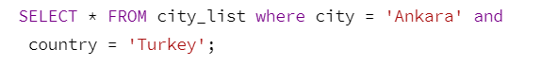





sdsd